5th Grade Science Homework October 7 - October 11

Monday
5.P.1.1

- What kind of force is gravity? What does gravity do?

5.P.1.2

- Jakai is going to the beach for vacation. Jakai traveled 450 miles in 9 hours to get to the beach. What was Jakai’s speed?

5.P.1.3

- Describe and draw a picture of what a line on a distance/time graph would look like if a train is stopped at a station.

Tuesday

5.P.1.1

What force is being put to use when applying the brakes on a bicycle?
- 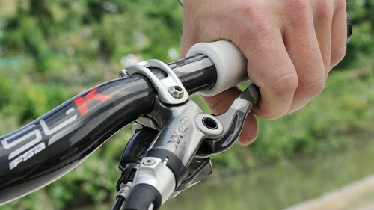
5.P.1.2

- Nylasha wants to calculate the speed of a train. What information does she need to calculate the speed of the train?

5.P.1.3

Alex is riding his bike around his neighborhood, starting at his house. How far away is Alex from home after riding his bike for only 5 seconds?
- 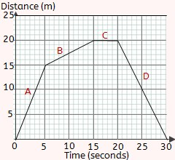

Wednesday

5.P.1.1

Which bag of marbles would take the least amount of force to pick up? How do you know this?
- 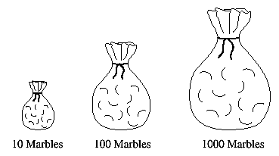
5.P.1.2

- A car traveled for an hour total. For the first half hour, the car traveled 40 miles. For the last 30 minutes, the car traveled 70 miles. What happened to the cars’ speed?

5.P.1.3

- I’m driving a car and the light in front of me is turning red so I need to slow down. Draw a graph that would best represent my car approaching the stop light.

